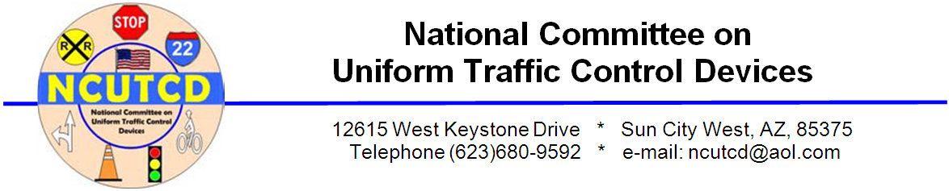

NOTE: In 2009, the National Committee on Uniform Traffic Laws and Ordinances (NCUTLO), which developed and maintained the Uniform Vehicle Code (UVC), went into hiatus. This left a void that the NCUTCD believes must be filled in order for its goal of uniformity of traffic control devices to be achieved and to provide guidance on model laws and rules for States and local governments. The Rules of the Road Committee (RORC) is an ad hoc committee of the NCUTCD to address changes to the “Rules of the Road” of the UVC.

Final recommended UVC content, as approved at a regular meeting of the NCUTCD, will be posted on the NCUTCD web site as model law for use by States and local jurisdictions wishing to have their Rules of the Road consistent with the national standard. The recommendations, not being a part of the Manual on Uniform Traffic Control Devices, have no status with the FHWA.

TECHNICAL COMMITTEE: Rules of the Road Committee (RORC)

TOPIC: Prohibiting use of hand-held wireless telephones while operating a motor vehicle
STATUS / DATE OF ACTION:
BTC Draft: 07/10/2012
BTC Approval:
Transmitted to Sponsors: (withdrawn from May2013 sponsor distribution)
BTC Revision:
RORC Approval:
Council Approval:

ORIGIN OF REQUEST: NCUTCD Rules of the Road Committee

AFFECTED SECTIONS OF UVC 11-(New section)

SUMMARY:

This change would prohibit use of a hand-held wireless telephone while operating a vehicle.

DISCUSSION:

Operation of a vehicle while sending or reading a text message is proving to be a serious hazard. 37 states, the District of Columbia and Guam have already banned texting for all drivers, see http://www.ghsa.org/html/stateinfo/laws/cellphone_laws.html. The following wording is based on California section 23123 and 23125, see http://www.dmv.ca.gov/pubs/vctop/d11/vc23123.htm and http://www.dmv.ca.gov/pubs/vctop/d11/vc23125.htm

RECOMMENDED CHANGES:

The UVC is proposed to be modified to add the following section. Insertions are shown in underline blue.

§ 11-***-Hand-Held Wireless Telephone: Prohibited Use
- A person may not drive a school bus or transit vehicle while using a wireless telephone.
- A person shall not drive a motor vehicle while using a wireless telephone unless that telephone is specifically designed and configured to allow hands-free listening and talking, and is used in that manner while driving.
- This section does not apply to a person using a wireless telephone for emergency purposes, including, but not limited to, an emergency call to a law enforcement agency, health care provider, fire department, or other emergency services agency or entity.
- This section does not apply to an emergency services professional using a wireless telephone while operating an authorized emergency vehicle, in the course and scope of his or her duties, or to the operator of a school bus or transit vehicle using a wireless telephone for work-related purposes.
- This section does not apply to a person while driving a motor vehicle on private property.

